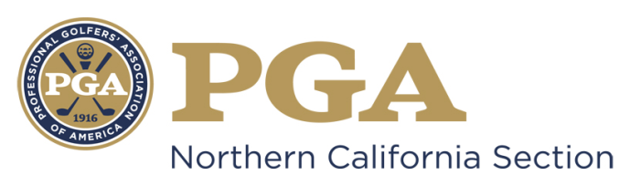

NCPGA SPECIAL AWARDS PROGRAM
NCPGA Assistant Associate of the Year Award

AWARD DESCRIPTION: The NCPGA Assistant Associate of the Year Award is designed to recognize a PGA Assistant Professional (A-8 or A-6) or Associate (Class B) for their overall performance as an Assistant or Associate. This award is based on a professional’s overall performance in leadership, service to the Section and community and promotion of the game of golf.
The NCPGA Special Awards Committee will adhere to the following guidelines and criteria for selecting the Section Award Winner:

Assistant Associate of the Year Award Guidelines:
- Demonstration of outstanding qualities of leadership
- Demonstration of strong moral character
- Maintain a substantial record of service to the Association and the game of golf.
- Well-regarded as a model PGA Golf Professional or Associate.

Assistant Associate of the Year Award Criteria:
- Criteria to Measure

  - Overall performance as an Assistant Golf Professional or Associate.
  - Service to the Assistant Associate Division, Chapter Section and the Association.
  - Leadership ability.
  - Image and ability to inspire fellow Golf Professionals and Associates.
  - Promotion and growth of the game of golf.

- Selection Process

  - Any PGA Assistant Professional or Associate (Class A-8, A-6 or Class B) in good standing meeting the outlined requirements. Class B Associates must be showing acceptable progress through the PGA PGM program. All nominees must be eligibly employed in the Section boundaries for at least two years.
  - Nomination should be based on a candidate’s entire past experience and commitment for continuing one’s contributions and assistance.
  - Achievements during the past five years should be emphasized.
  - Section Awards Committee will select recipient based on criteria.
  - Nominees will be notified by the Special Awards Committee Chairman regarding award determination status no later than September 10th.

- Ineligible Categories

  - Previous National PGA Golf Professional of the Year Award winners
  - Past Presidents of the National PGA Association
  - Current members of the PGA of America Board of Directors
  - Nominees for PGA National Office
  - Class “F” and “Inactive” members
  - PGA National Headquarters staff and PGA Section staff (with the exception of PGA Golf Properties and Section Golf Properties staff)
  - Members of the NCPGA Special Awards Committee

Other Considerations:

- You are marketing yourself and your facility with this nomination. Be sure to make every effort possible to present yourself and your facility in the most positive perspective possible. Be sure to include descriptive examples in order to emphasize your achievements.

- Should you be selected as the NCPGA Special Award Winner only the following awards will be submitted for PGA of America Special Award: Golf Professional of the Year, Horton Smith, Bill Strausbaugh, Youth Player Development, Teacher of the Year, Merchandisers of the Year, Player Development Award, and Patriot Award.
- Section Awards will be presented at the annual NCPGA Special Awards Ceremony and Annual Membership meeting in December.

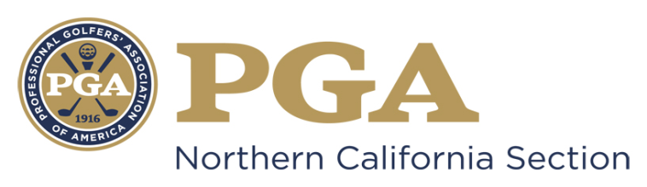

NCPGA SPECIAL AWARDS NOMINATION
NCPGA Assistant Associate of the Year Award

Type Your Answer in Area Marked “x” Below
Name of Nominee: x
Member Number: x
Facility Name: x
Facility Address: x
Facility Phone Number: x
Nominee E-mail Address: x
Nomination submitted by: x
Nominator Contact Information: x

The nomination form should be typewritten and completed in the THIRD-PERSON.
- Please state how the contributed to the betterment of the Northern California Section of the PGA. Be sure to include and describe any Section committee, chapter or division activity as well as National PGA or industry initiatives Nominee has supported at the facility level.
- In what ways has the Nominee offered support to the NCPGA Assistant Associate Association?
- To date, what has been his/her involvement with the PGA Professional Golf Management Program?

- What has the Nominee done at his/her facility for junior golf?
- What contributions has the Nominee made within his/her community for the betterment of others, through the game of golf or otherwise?
- Letters of recommendation attesting to Nominee’s attributes and service to the Section are encouraged. Please attach the letter(s) to your nomination packet.
- Please list any Section or National awards the Nominee has received

Award | Year Received | Section

By signing this form (or personally submitting via email), I attest that the information contained herein is accurate and truthful to the best of my knowledge, and that the nominee has been informed of, and has consented to, this Section Nomination.

________ ____ ____ ___ ______
Submitter’s Signature Date Nominee’s Signature Date

Nomination Deadline: July 31st

Submit Complete Nomination Form to:

Suzy Schneider, NCPGA
411 Davis Street, Suite 103
Vacaville, CA 95688
sschneider@pgahq.com
PH (707) 449-4742 / FX (707) 449-4755

- Unsigned, Incomplete and/or Ineligible Nomination Forms will NOT Be Considered.
- An electronic copy (Microsoft Word Document) must be submitted to the NCPGA Section Office.

