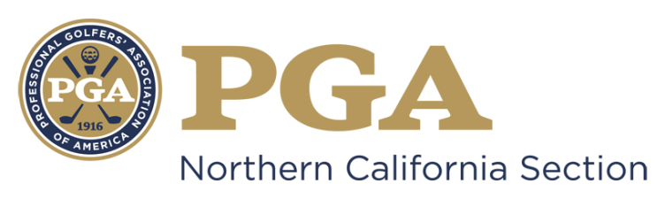

NCPGA SPECIAL AWARDS PROGRAM
NCPGA Patriot Award

The NCPGA Patriot Award bestows special recognition on a PGA Golf Professional, who personifies patriotism through the game of golf and demonstrates unwavering commitment and dedication to the men and women who have valiantly served and protected the United States of America.

Requirements:
- Candidate must be a PGA member in good standing.
- Candidate must be well regarded as a model PGA member.
- Demonstration and acknowledgement as an individual of outstanding leadership and strong moral character.

Eligibility:
The following persons are ineligible:
- Previous National Patriot Award winners;
- Past Presidents of the Association;
- Current members of the Association Board of Directors;
- Nominees for National Office;
- Class "F" or "Inactive" members; or Associates;
- PGA National Headquarters Staff and PGA Section Staff are not eligible for National Awards (Excluding Employees of PGA Golf Properties or Section Golf Properties);
- Members of the NCPGA Special Awards Committee.

Criteria:
- *NOTE: In order to be submitted on behalf of the Section to the PGA National Awards Program, NCPGA Award Winners must currently be a Class A PGA member in good standing and involved in military programming efforts as either a PGA Associate or Member for a minimum total of 10 years.
- Candidate must have maintained a substantial record of contribution and support to the United States Armed Forces and its Active Duty and Reserved personnel and veterans.
- Candidate must have displayed proven interest, concern, and ability to provide opportunities and experience for active duty, reservists, and veterans to learn and play golf.
- Candidate must have shown an ability to inspire fellow PGA members with an emphasis in the area of service to the military.
- Candidate must have maintained a continual record of service, promotion of the game of golf and proven interest and ability to provide opportunities and experiences for military personnel to learn, play and participate in the game.

Guidelines for Selection:
The candidate will be considered on the basis of the following:
- Their entire PGA career with the primary emphasis on the service and commitment for the military;
- The overall contribution to programs and events including, but not limited to, Patriot Golf Day, which supports the Armed Forces and veterans, and such program impact;
- The overall involvement in the promotion and development of targeted golf programs at the club, Section and National levels, as well as within the community for military personnel and veterans;
- The active support and contribution of the Armed Forces and veterans through community activities at-large;
- Overall integrity and recognition as a person of outstanding character by PGA Professionals and leaders within the community;
- Other contributions provided to The PGA.
- Nominees will be notified by the Special Awards Committee Chairman regarding award determination status no later than September 10th.

Other Considerations:

- Due to the nature of this award, it may not be awarded on an annual basis.
- REMINDER: You are marketing yourself and your facility with this nomination. Be sure to make every effort possible to present yourself and your facility in the most positive perspective possible. Be sure to include descriptive examples in order to emphasize your achievements.
- Should you be selected as the NCPGA Special Award Winner, this nomination information will be submitted for National Consideration. Only the following awards will be submitted for PGA of America Special Award: Golf Professional of the Year, Horton Smith, Bill Strausbaugh, Youth Player Development, Teacher of the Year, Merchandisers of the Year, Player Development Award, and Patriot Award.
- Section Awards will be presented at the NCPGA Special Awards Ceremony held in December.

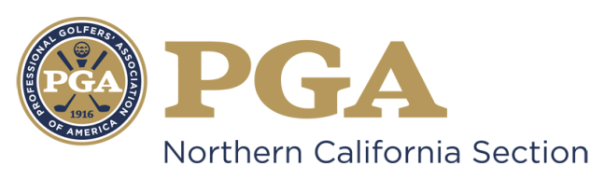

NCPGA SPECIAL AWARDS NOMINATION
NCPGA Patriot Award

Type Your Answer in Area Marked “x” Below
Name of Nominee: x
Member Number: x
Facility Name: x
Facility Address: x
Facility Phone Number: x
Nominee E-mail Address: x
Nomination submitted by: x
Nominator Contact Information: x

*NOTE: In order to be submitted on behalf of the Section to the PGA National Awards Program, NCPGA Award Winners must currently be a Class A PGA member in good standing and involved in military programming efforts as either a PGA Associate or Member for a minimum total of 10 years.

The nomination form should be typewritten and completed in the THIRD PERSON.

- Please describe the Nominee’s involvement in the promotion and development of targeted player development golf programs at the club level and within the community for military personnel and veterans.

- Please describe the Nominee’s contributions to programs and events, including Patriot Golf Day, which supports the Armed Forces and veterans.

- Please describe the Nominee’s image, service and leadership in the area of support for the military, its personnel and veterans.

- Please describe how the Nominee inspires fellow PGA Professional in his/her support and contributions to the Armed Forces.

- Please provide any additional information regarding the Nominee and his/her contributions relevant to The Patriot Award.

- Please list any Section or National awards the nominee has received.

Award | Year Received | Section

By signing this form (or personally submitting via email), I attest that the information contained herein is accurate and truthful to the best of my knowledge, and that the nominee has been informed of, and has consented to, this Section Nomination.

________ ____ ____ ___ ______
Submitter’s Signature Date Nominee’s Signature Date

Nomination Deadline: July 31st

Submit Complete Nomination Form to:
Suzy Schneider, NCPGA
411 Davis Street, Suite 103
Vacaville, CA 95688
sschneider@pgahq.com
PH (707) 449-4742 / FX (707) 449-4755

- Unsigned, Incomplete and/or Ineligible Nomination Forms will NOT Be Considered.
- An electronic copy (Microsoft Word Document) must be submitted to the NCPGA Section Office.

