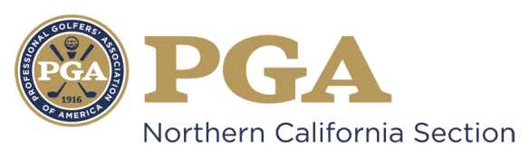

NCPGA SPECIAL AWARDS PROGRAM
NCPGA Bill Strausbaugh Award

The "NCPGA Bill Strausbaugh Award" bestows special recognition on a PGA Golf Professional, who personally displays outstanding integrity, character, and leadership through a commitment to mentoring and making significant impacts on the careers of PGA Professionals. In the spirit of the award, “mentoring” shall be defined as follows:
“Mentoring is supporting professionals to manage their own development so they can maximize their PGA career potential. The PGA mentor empowers, enables, advises, challenges, and encourages professionals to enhance their professional skills, strengthen their level of service, improve their work performance, and become the PGA Member that they aspire to be.”
Requirements:
- Candidate must be a PGA member in good standing.
- Candidate must be well regarded as a model PGA member.
- Demonstration and acknowledgement as an individual of outstanding leadership and strong moral character.

Eligibility:
The following persons are ineligible:
- Previous National Bill Strausbaugh Award winners;
- Past Presidents of the Association;
- Current members of the Association Board of Directors;
- Nominees for National Office;
- Class "F" or "Inactive" members;
- Associates;
- PGA National Headquarters Staff and PGA Section Staff are not eligible for National Awards (Excluding Employees of PGA Golf Properties or Section Golf Properties).
- Members of the NCPGA Special Awards Committee

Criteria:
- *NOTE: In order to be submitted on behalf of the Section to the PGA National Awards Program, NCPGA Award Winners must be a Class A PGA member in good standing for a minimum total of 10 years.
- Candidate must have maintained a substantial record of service to the PGA of America in the effort to further the careers of fellow PGA Professionals as a mentor, counselor, teacher and advisor.
- Candidate has developed the image, reputation, and ability to inspire fellow PGA members with an emphasis in the area of leadership and service to the Association, individual PGA Professionals and the community at-large.
- Candidate must have maintained a continual record of service and promotion of the game of golf and golf industry within the specific area of employment and club relations.

Guidelines for Selection:
The candidate will be considered on the basis of the following:
- Their entire PGA career with the primary emphasis on the service and commitment for mentoring fellow PGA Professionals as defined in the mentoring statement;
- Their performance and service to the Association and Section to include contributions to building and growing the image of the PGA Professional, the Association and game of golf through mentoring, as well as within the area of employment and club relations;
- The significant impacts made on fellow Golf Professionals resulting in the advancement of skills, knowledge, work performance, and ultimately career advancement;
- The significant influence made on PGA Professionals, facilities, and employers within employment and club relations resulting in the advancement of the PGA’s mission;
- Overall integrity and recognition as a person of outstanding character by PGA Professionals and leaders within the community;
- Other contributions provided to The PGA.
- Nominees will be notified by the Special Awards Committee Chairman regarding award determination status no later than September 10th.

Other Considerations:
- REMINDER: You are marketing yourself and your facility with this nomination. Be sure to make every effort possible to present yourself and your facility in the most positive perspective possible. Be sure to include descriptive examples in order to emphasize your achievements.
- Should you be selected as the NCPGA Special Award Winner, this nomination information will be submitted for National Consideration. Only the following awards will be submitted for PGA of America Special Award: Golf Professional of the Year, Horton Smith, Bill Strausbaugh, Youth Player Development, Teacher of the Year, Merchandisers of the Year, Player Development Award, and Patriot Award.
- Section Awards will be presented at the NCPGA Special Awards Ceremony held in December.

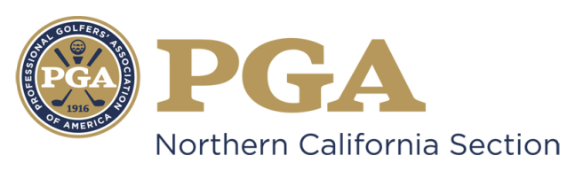

NCPGA SPECIAL AWARDS NOMINATION
NCPGA Bill Strausbaugh Award

Type Your Answer in Area Marked “x” Below
Name of Nominee: x
Member Number: x
Facility Name: x
Facility Address: x
Facility Phone Number: x
Nominee E-mail Address: x
Nomination submitted by: x
Nominator Contact Information: x

*NOTE: In order to be submitted on behalf of the Section to the PGA National Awards Program, NCPGA Award Winners must be a Class A PGA member in good standing for a minimum total of 10 years.

The nomination form should be typewritten and completed in the THIRD-PERSON.

- Please briefly describe the Nominee’s involvement and contributions through mentoring PGA Professionals and illustrate a significant impact on their careers.

- Please briefly describe the characteristics of the Nominee relative to overall integrity and recognition as a person of outstanding character. How has he/she furthered the values representative of the Association and the golf profession?

- Please briefly describe the Nominee’s level of service to the Section and to the Association with the area of employment and club relations.

- Please briefly describe the Nominee’s influence made of PGA Professionals, facilities, and employers with regard to employment.

- Please briefly describe the Nominee’s contributions to building the image of the game of golf, PGA Professionals and the Association.

- Please list any Section or National awards the Nominee has received

Award | Year Received | Section

By signing this form (or personally submitting via email), I attest that the information contained herein is accurate and truthful to the best of my knowledge, and that the nominee has been informed of, and has consented to, this Section Nomination.

________ ____ ____ ___ ______
Submitter’s Signature Date Nominee’s Signature Date

Nomination Deadline: July 31st

Submit Complete Nomination Form to:

Suzy Schneider, NCPGA
411 Davis Street, Suite 103
Vacaville, CA 95688
sschneider@pgahq.com
PH (707) 449-4742 / FX (707) 449-4755

- Unsigned, Incomplete and/or Ineligible Nomination Forms will NOT Be Considered.
- An electronic copy (Microsoft Word Document) must be submitted to the NCPGA Section Office.

