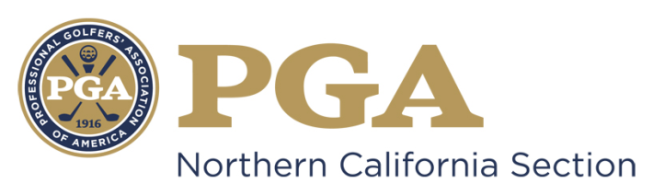

NCPGA SPECIAL AWARDS PROGRAM
Youth Player Development Award
The "PGA Youth Player Development Award" bestows special recognition on a PGA Golf Professional, who has displayed extraordinary and exemplary contribution and achievement in the area of youth player development. The award considers the PGA Professional’s focus on Youth through their growth of the game leadership, commitment at the Section and National levels in the youth player development arena, and the meaningful impact made upon youth through the introduction and participation in the game.
Requirements:
- Candidate must be a PGA member in good standing.
- Candidate must be well regarded as a model PGA member.
- Demonstration and acknowledgement as an individual of outstanding leadership and strong moral character.
Eligibility:
- The following persons are ineligible:
- Previous National PGA Youth Player Development award winners;
- Past Presidents of the Association;
- Current members of the Association Board of Directors;
- Nominees for National Office;
- Class "F" or "Inactive" members;
- Associates;
- PGA National Headquarters Staff and PGA Section Staff are not eligible for National Awards (Excluding Employees of PGA Golf Properties or Section Golf Properties);
- Members of the NCPGA Special Awards Committee.
Criteria:
PGA Youth Player Development Award minimum criteria:
- *NOTE: In order to be submitted on behalf of the Section to the PGA National Awards Program, the NCPGA Award Winner must currently be a Class A PGA member in good standing and involved in youth player development efforts as either a PGA Associate or Member for a minimum total of 10 years.
- Candidate must have maintained a substantial record of service to the PGA of America, Section, facility, and golf industry in the area of Youth Player Development.
- Candidate has developed the image, reputation, and ability to inspire fellow PGA members with an emphasis in the area of Youth Player Development.
- Candidate must have maintained a continual record of service, promotion of the game of golf, as well as proven interest and ability to provide opportunities and experiences for youth to learn, play and participate in the game.
Guidelines for Selection: The candidate will be considered on the following:
- Their entire PGA career with the primary emphasis on the service and commitment for Youth Player Development;
- The overall impact of Youth Player Development programs implemented at the facility and within the community. This impact will include assessments of successful programming to include player introduction, customer satisfaction, development of individual character and values, and retention into adulthood;
- The overall quality and mixture of the Youth Player Development programming to include the broad range of opportunities for players of all skill levels, the uniqueness of ideas, and the number of best practices utilized;
- The use and implementation of PGA of America Youth golf programming such as PGA Junior League, PGA Sports Academy, as well as Section provided programming;
- Any significant influence made on Golf Professionals, participants, the community, facilities, and employers within the area of Youth Player Development;
- The performance and service to the Association and Section to include contributions to building and growing the image of the PGA Professional and The PGA through the promotion of golf and the golf industry;
- Overall integrity and recognition as a person of outstanding character by PGA Professionals and leaders within the community;
- Other contributions provided to The PGA.
- Nominees will be notified by the Special Awards Committee Chairman regarding award determination status no later than September 1st of the current year.

Other Considerations:
- REMINDER: You are marketing yourself and your facility with this nomination. Be sure to make every effort possible to present yourself and your facility in the most positive perspective possible. Be sure to include descriptive examples in order to emphasize your achievements.
- Should you be selected as the NCPGA Special Award Winner, this nomination information will be submitted for National Consideration. Only the following awards will be submitted for PGA of America Special Award: Golf Professional of the Year, Horton Smith, Bill Strausbaugh, Youth Player Development, Teacher of the Year, Merchandisers of the Year, Player Development Award, Patriot Award.
- Section Awards will be presented at the NCPGA Special Awards Ceremony and Annual Membership Meeting in December.

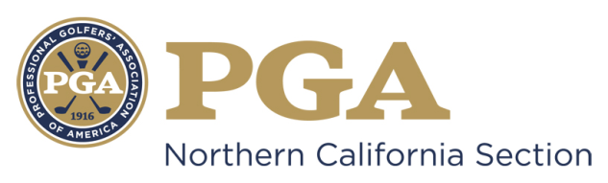

NCPGA SPECIAL AWARDS NOMINATION
Youth Player Development Award

Type Your Answer in Area Marked “x” Below
Name of Nominee: x
Member Number: x
Facility Name: x
Facility Address: x
Facility Phone Number: x
Nominee E-mail Address: x
Nomination submitted by: x
Nominator Contact Information: x

*NOTE: In order to be submitted on behalf of the Section to the PGA National Awards Program, the NCPGA Award Winner must currently be a Class A PGA member in good standing and involved in youth player development efforts as either a PGA Associate or Member for a minimum total of 10 years.

The nomination form should be typewritten and completed in the THIRD-PERSON.
- Please briefly describe the Nominee’s contributions to youth golf programs in the Section and on a National level including service as a chairperson or a member of the Junior Golf Committee/Youth Player Development Committee.

- Please briefly describe the Nominee’s involvement in the promotion and development of youth golf at the club level and within the community.

- Please briefly describe the Nominee’s image and leadership in the area of youth golf and how it impacts/illustrates your overall integrity.

- Please briefly describe how the Nominee inspires fellow PGA Professionals and promote the game of golf.

- Please describe any unusual, innovative or extraordinary youth golf programs that the Nominee has developed or played a role in implementing.

- Please list any Section or National awards you have received

Award | Year Received | Section

By signing this form (or personally submitting via email), I attest that the information contained herein is accurate and truthful to the best of my knowledge, and that the nominee has been informed of, and has consented to, this Section Nomination.

________ ____ ____ ___ ______
Submitter’s Signature Date Nominee’s Signature Date

Nomination Deadline: July 31st

Submit Complete Nomination Form to:

Suzy Schneider, NCPGA
411 Davis Street, Suite 103
Vacaville, CA 95688
sschneider@pgahq.com
PH (707) 449-4742 / FX (707) 449-4755

- Unsigned, Incomplete and/or Ineligible Nomination Forms will NOT Be Considered.
- An electronic copy (Microsoft Word Document) must be submitted to the NCPGA Section Office.

